Parameters
input_turbidity Off (default)
input_turbidity On (followed by array of turbidity values for each day)

Calculations
If no turbidity value is given at a river segment that is not a confluence, turbidity for a specific day is calculated:
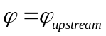
where
- 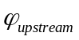 is the turbidity at the upstream segment for that day
If the river segment is a confluence and no overriding value is given, turbidity for a specific day is calculated:
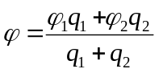
where
- the “two upstream segments” refers to the segments pointed to by the up and fork pointers in the C structure
- 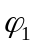 and 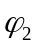 are the two upstream segments’ turbidities for that day
- 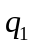 and 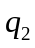 are the two upstream segments’ flows for that day

